MONTSERRAT VOLCANO OBSERVATORY

GOVERNMENT OF MONTSERRAT

An overview of banded tremor at the Soufriere Hills Volcano, 1996 - 2001

Glenn Thompson

MVO Open File Report 01/02

MONTSERRAT VOLCANO OBSERVATORY

GOVERNMENT OF MONTSERRAT

An overview of banded tremor at the Soufriere Hills Volcano, 1996 - 2001

Glenn Thompson

MVO Open File Report 01/02

Montserrat Volcano Observatory
PO Box 292
Montserrat
West Indies

Tel: 1 664 491 5647
Fax: 1 664 491 2423
Email: mvomail@mvo.ms

* Affiliation inside cover

Affiliation of author

Glenn Thompson
Montserrat Volcano Observatory
Mongo Hill
Montserrat
West Indies

Table of Contents

1 Introduction 1
2 Data Analysis 3
3 Results so far 4
3.1 Episodes of banded tremor 4
3.2 The relation between banded tremor / hybrid swarms and dome collapses 6
3.3 Re-examining the tilt-seismicity cycles in 1997 8
4 Discussion 9
5 Work in progress 10
References 12

Executive Summary

RSAM and tiltmeter data were analysed from the period 1996 – 2001 to determine the episodes of banded tremor (or other cyclic seismicity) that has occurred. Eight episodes were found, and the vast majority of dome collapses above about 1 million cubic metres have been shown to be occur in close temporal proximity with seismicity cycles or hybrid swarms (which are a related phenomenon). However in phase 1 of dome growth, seismicity generally preceded collapses, whereas in phase 2 of dome growth, seismicity has followed collapses.
The tilt/seismicity cycles from June-September 1997 were examined in more detail. It was found that tilt preceded seismicity by about 1.2 hours, or 30o on average. Cycles were found to increase slowly, and decline more abruptly. There was a suggestion that seismicity and tilt cycle amplitudes are correlated.

Introduction
Since the eruption of the Soufriere Hills Volcano on Montserrat began on the 18th of July 1995, the primary technique by the Montserrat Volcano Observatory has been seismic monitoring, and this has led a wealth of interesting observations, many of which have yet to be documented. An intriguing feature of the seismicity has been the occurrence of episodes of cyclic hybrid swarms. These hybrid swarms usually begin with events a few minutes apart, which then become closer and closer together, until they (usually) merge into continuous tremor [Fig. 1]. Typically after 1 hour or more of tremor, the sequence is reversed, as distinct events emerge once more from the tremor. This cycle then repeats a few hours later. The periodicity of these cycles has varied between 3 and 24 hours, and the phenomenon has been recorded in ‘episodes’ lasting from a few days to a few months. This type of tremor is often referred to as “banded tremor” because of its appearance on drum records [Fig. 2]. In spectrograms, once events began to overlap and merge closer together, gliding lines should be observed [Fig. 3].
Banded tremor has been recorded on many volcanoes including Izu-Oshima, Etna, Nevado del Ruiz, St. Helens and Pinatubo. It has also been recorded at Old Faithful Geyser, suggesting a hydrothermal origin.
Tremor bands were first recognised in the RSAM data on 29 July 1996 [Fig. 4], and it was immediately postulated that there were indicative of pressure cycles, probably within the shallow magmatic system, since they visually correlated with increased degassing, ash venting and rockfalls from the dome [Thompson, 1996] . An interesting observation was the apparent reduction in amplitude of tremor bands following dome collapse events in July/August 1996, suggesting there was less need for pressure to develop.
Conclusive evidence of the link between pressure cycles and banded tremor was obtained in the summer of 1997, when a tiltmeter station operating on Chances Peak, less than 2 km from the dome, recorded the expansion and subsequent contraction of the volcanic edifice associated with these tremor bands. It was determined that the onset of pressurisation (tilt cycle) preceded the onset of the hybrid swarm/tremor band, and this led to models [Voight et al., 1999]. Denlinger and Hoblitt [1999] developed a model suggesting that these cycles were a consequence of an increase of the supply rate of magma into the conduit. In 1999 the SO2 emissions (detected using a COSPEC instrument) associated with an episode of banded tremor were captured for the first time [Young et al., 2000], leading to a model where pressure builds beneath a cap in the conduit, this cap is then moved or fractured (seismicity), and there is sudden release of gas. Further simultaneous collection of strain or tilt data at a site close to the dome, and gathering of high temporal resolution SO2 flux data (as should be possible with the DOAS system currently under development) are required before a more detailed evaluation of these models can be made.
Strong seismicity cycles occurred prior to the fatal 25 June 1997 collapse (these can be seen in Figures 5 and 6), were associated with a series of Vulcanian explosions throughout August and September 1997, and also preceded the devastating 21 September 1997 collapse [Figure 8]. They were also used as a real-time hazard mitigation tool, with the MVO Operations Room instructing field parties to withdraw to a safe position whenever a new cycle began to be recorded. Crucially this was used by then Chief Scientist Willy Aspinall as an indicator for MVO scientists Rob Watts and Amanda Clarke to retreat to the airport minutes before the 25 June 1997 collapse started.
Further important observations of banded tremor followed the large dome collapse of 20 March 2000 when cycles were recorded for about 4 weeks [Thompson et al., 2000] and were sometimes associated with strong ash venting (which sometimes glowed) reminiscent of Strombolian activity. In February 2001, the onset of an increase in seismicity was predicted on the basis of a different kind of cyclic seismicity – 14 week cycles which appeared to mark a change in the rate (and sometimes direction) of dome extrusion. Pyroclastic flows reached the delta along the White River, entirely unexpectedly, and then intense growth began occurring to the north-east. Coincident with this, high amplitude banded tremor began occurring on 26 February and lasted for 1 week. Then immediately following the large dome collapse of 29 July 2001 [Thompson et al., 2001], banded tremor occurred once more, and lasted for about 2 months during which rapid dome growth occurred. This was unusual not only because this episode lasted so long, but because tremor/hybrid swarms were often not present, but instead there was banded rockfall activity, suggesting pressurization cycles were ongoing.
Banded tremor is clearly an interesting and important phenomenon to understand in terms of learning about how the Soufriere Hills Volcano works and for mitigating hazards, and this is the first attempt to provide an overview of all the banded tremor episodes that have been recorded by the MVO.
All previous studies have been based on analysis of short sequences of data. The aims of this study were:
- Identify all episodes of banded tremor at the Soufriere Hills Volcano so far.
- Measure the amplitude, approximate shape of each band, and the interval between bands.
- Correlate these parameters with tilt and rockfall activity.
- Note timing of these bands in relation to large dome collapse events.
- Summarise results.

Data Analysis
Research into the seismicity of the Soufriere Hills Volcano was greatly enhanced by the installation of the digital seismic network in October 1996. Key advantages of the digital network over the analog network include the high-dynamic range (24-bit) telemetry, and continuous data recording. There has not yet been any systematic study of these continuous data from the period May – September 1997 to examine the link between tilt and seismicity. However, study of these data is laborious, requiring significant time and storage resources to extract what amounts to about 60 GB of data from old DDS-1 DAT tapes, untar and unzip them, and develop programs to analyse them efficiently. We save this for a later study.
The main data used in this study were 1-minute-averaged seismic amplitude (RSAM) data. These data, computed in real-time, are much more amenable for the purposes of identifying seismicity cycles. Tilt data are also used where available. In April 2001, the binary formats of the RSAM and TILT data were decoded and programs written to load these into Matlab. Each binary file consists of a 4-byte integer for every minute of the year (that is 60 * 60 * 24 * 365 samples for a non-leap year), with a 1 day header (1440 samples). Time is therefore coded by the position of each sample within the file. The routines written to import these into Matlab were import_rsam.m, load_rsam.m, and import_tilt.m).
Another potential dataset were the detected events. Figure 4 shows a comparison of RSAM, TILT and detected rockfall signals and hybrid earthquake signals for a period in June – July 1997. The detected events datasets are not a good way to identify seismicity cycles because detection is based on a standard sta:lta algorithm, where a certain ratio (usually around 3) must be exceeded to declare a trigger. During tremor bands the lta value is high, meaning only large amplitude events will be detected. Detection becomes very insensive during tremor bands, and thus we chose to ignore the these datasets, and concentrate on RSAM and TILT instead.
Unfortunately, there is no seismic station that has operated continuously throughout the eruption, so data from different stations had to be used for different time periods. Routine processing over many years has shown that the lowest noise seismic site and the one best suited for event classification is Windy Hill, about 2 km north of the dome. Windy Hill is also the best reference station for amplitude measurements because it is on the opposite side of the dome to most rockfall and pyroclastic flow activity, so it does not show significant bias. There are two stations co-located at Windy Hill. Station MWHZ is part of a 6-station analog network installed by a team from the US Geological Survey and Seismic Research Unit of the University of the West Indies at the beginning of the eruption in July 1995. Station MBWH is part of an 8-station digital network installed in October 1996 by the British Geological Survey. The digital telemetry used for MBWH make this the preferred station, but these data were only available prior to March 2000. Prior to this data from station MWHZ are used where available, otherwise station MLGT (Long Ground) is used.
It was necessary to work out scaling relations between these different stations, so that amplitudes could be meaningfully compared from one episode to another. By examining the amplitude of dome collapses and tremor bands that appeared on all three instruments, and taking MBWH as unity, it was found that a scaling factor of 0.65 had to be applied to MWHZ and 0.5 to MLGT. To then turn the raw counts from MBWH into meaningful values, the reduced displacement was computed using known response data and the surface wave formulation of Fehler [1983].
We wrote a Matlab program detectcycles.m to sift through the entire RSAM dataset from 1996-2001 and identify any episodes of cyclic seismicity. RSAM data were available from the analog seismic network since July 1995. From 20 March 2000 they were also available for the digital seismic network. detectcycles.m employed a simple STA:LTA trigger, but in this case the window for the short-term average was about 30 minutes and the window for the long-term average 2 hours. The trigger ratio was 1.5, and the detrigger ratio 0.7. Triggers from this subroutine were then passed into an associator subroutine which looked for times where at least 3 triggers were recorded in the space of one week. This were identified as periods for further analysis.
We then wrote a program pickcycles.m to analyse these episodes. Starting several days before each candidate episode, we visually inspected the RSAM dataset and simultaneous TILT dataset if available. Using a simple graphical user interface, the start, peak and end of each tilt and seismicity cycle were picked with the mouse. The window scrolled to later data as the picking progressed. Time/amplitude pairs were stored to files. These files formed the data for the final stage of this study.
The final part of the current study was analyse these time/amplitude pairs for the the seismicity and tilt cycles, for which a program statistics.m was written.

Results so far

Episodes of banded tremor
We identified 8 episodes of banded tremor [Table 1] and a total of 645 cycles, using a criterion of at least 4 cycles to define an episode. Episodes last from 3 weeks to 3 months, with the exception of the unusual activity in February-March 2001, which lasted just 1 week. The average period was 9 hours, but range from 3-24 hours, and episode means from 7-13 hours. The strongest reduced displacement values were around 5 cm² but typically values were around 1 cm², and the detection threshold as low as 0.1 cm², though possibly much higher during times of intense seismicity. Tilt cycles were only recorded in 1997 due to the proximity of tilt stations to the volcano.
No link between tremor band amplitude and period was found.

Start date | End date | Number of cycles |  | Mean interval  (hours) |  | Mean cycle amplitude (cm²) |  | Maximum cycle amplitude  (cm²) |  | Stations showing tilt cycles |  | RSAM stations
28-Jul-1996 | 13-Sep-1996 | 123 |  | 7 |  | 1.5 |  | 5.0 |  | None. LONG has data up to 12/7/96. |  | MLGT  (22 Jul – 15 Sep?)
12-Dec-1996 | 8-Feb-1997 | 92 |  | 10 |  | 1.3 |  | 5.1 |  | LONG and CHPK show diurnal cycles. |  | MLGT  (particularly 2-6 Jan)
23-May-1997 | 2-Sep-1997 | 116 |  | 12 |  | 1.1 |  | 4.6 |  | CHP3 shows cycles from 22/5/97-10/7/97, and |  | MWHZ  (particularly 22 May – 10 Jul, 31 Jul – 5 Aug, 10-20 Aug
4-Feb-1998 | 25-Feb-1998 | 33 |  | 11 |  | 0.7 |  | 2.5 |  |  |  | MLGT (31 Jan – 25 Feb)
1-Nov-1999 | 20-Feb-2000 | 151 |  | 9 |  | 0.4 |  | 2.0 |  |  |  | MLGT (why not MBWH or MBLG)  Particularly 19-31 Dec, 1-6 Jan
22-Mar-2000 | 16-Apr-2000 | 82 |  | 7 |  | 0.3 |  | 1.3 |  |  |  | MBWH (what about MBLG?)  Particularly 23-26 Mar, 1-9 Apr
26-Feb-2001 | 03-Mar-2001 | 9 |  | 12 |  | 2.3 |  | 4.8 |  |  |  | “
13-Aug-2001 | 08-Nov-2001 | 39 |  | 13 |  | 0.6 |  | 1.5 |  |  |  | “
ALL |  |  | 645 |  | 10 |  | 1.0 |  | 5.1

Table 1: Statistics of cyclic tremor episodes. These generally occur at times of rapid extrusion, suggesting that hybrid swarms, and banded tremor in particular, are symptoms of unusually high pressure gradients. Data from March 2000 onwards are from MBWH. Data from May-Sep 1997 are from MWHZ, scaled by 0.65. All other data are from MLGT, scaled by 0.5.

The relation between banded tremor / hybrid swarms and dome collapses
Its interesting to compare major collapse and explosive events with the timing of tremor episodes [Table 2]. There are 28 events listed here, 21 of them prior to the end of 1997. Of these 15 are coincident with cyclic seismicity. In all, 18 out of 21 are coincident with some manifestation of hybrid swarms, whether cyclic or not.
Furthermore, the event on 17 September 1996 occurred just 4 days after a 7 week long episode of cyclic seismicity had occurred. Closer examination of RSAM data reveals that weak cycles were still evident right up to the start of this collapse and explosive event [Figure 7]. This was not mentioned in the MVO Special Report written about this major event, suggesting the scientists at the time were not aware of it. It is however an important observation. So there is conclusive evidence of swarms or tremor being associated with 19 out of 21 significant collapse events in 1996 – 1997.
During the period of no dome growth from April 1998 to October 1999, there were no episodes of cyclic seismicity, strongly suggesting cyclic seismicity is associated with the extrusion process. Calder reports 4 events during this period, including significant collapses on 3 July 1998 and 20 July 1999. These may have been passive dome collapses, or triggered by rainfall [Thompson et al., 2000; 2001].
When dome growth reactivated in November 1999, cyclic seismicity was observed for about 15 weeks [Thompson, 2000]. The major dome collapse on 20 March 2000 was followed by over 3 weeks of cycles [Figure 9]. The small (but energetic) collapses which reached the sea along Whites Ghaut and Tuitt's Ghaut on the 24th and 25th of February 2001 were followed by the strong cycles similar in intensity to cycles recorded in 1996 and 1997 [Figures 10, 11 and 12]. The major dome collapse of 29 July 2001, was not followed by seismicity cycles within 7 days. However, cycles were identifiable 2 weeks later [Figure 13], and continued for 3 months [Figure 14]. The period slowly changed.

Date | Volume of collapse  (courtesy of Eliza Calder)  * includes surge deposit volume. | Nearest occurrence of cyclic seismicity
29 July 1996 | 2.8/3.0* | 0 days
31 July 1996 | ~1.0 | 0 days
4 August 1996 | ~3.0 | 0 days
11 August 1996 | 3.2/3.5* | 0 days
21 August 1996 | 2.9/2.9* | 0 days
2 Sept 1996 | ~2.0 | 0 days
3 Sept 1996 | ~3.0 | 0 days
17 Sept 1996 | 11.8/12.3* | 4 days (0 days on closer inspection; Figure 7)
19 Dec 1996 | ~4.0 | 0 days
9 January 1997 | ~2.0 | 0 days
13 January 1997 | ~2.0 | 0 days
16 January 1997 | ~3.0 | 0 days
20 January 1997 | ~3.0 | 0 days
30 March 1997 | 2.6/2.6* | none
11 April 1997 | 2.9/3.0* | none
25 June 1997 | 5.5/6.4* | 0 days
3 August 1997 | 8.8/9.1* | 0 days
21 September 1997 | 13.6/14.3* | 0 days
4 November 1997 | ~2.0 | None, but there was a powerful hybrid swarm
6 November 1997 | ~6.0 | None, but there was a powerful hybrid swarm
26 December 1997 | 55/58* | None, but there was a powerful hybrid swarm
3 July 1998 | 20-25 | none
5 November 1998 | ~1.0 | none
12 November 1998 | ~3.0 | none
20 July 1999 | ~5.0 | none
20 March 2000 | ~30 | Began 2 days afterwards, and lasted for over 3 weeks
24/25 February 2001** | ~ 2 | Began the next day
29 July 2001 | ~40-50 | Began 15 days afterwards, and lasted for over 12 weeks
Table 2: Major collapse events 1996-2001 with an estimate of the amount of dome material involved and temporal relation to cyclic seismicity. ** Event added by author.
A visual representation of the detected cycles versus time is given in Figure 15, though this excludes the episode of August-November 2001. The range in period is shown in Figure 16, and appears to be approximately log-normal, suggesting a recharge mechanism involving some kind of reservoir which fills more slowly depending on the pressure difference driving flow.

Re-examining the tilt-seismicity cycles in 1997
Given that the June-September 1997 was the only period during which tilt recordings were successful made in conjunction with RSAM data, we examine this a little further. In Figure 17, the time delay and phase delay between tilt and seismicity cycles are shown as a function of time. Here it is the times of the peak amplitudes of the cycles that are compared, since these are easier to pick that onset or end times. This is done by taking all occasions where a tilt and seismicity overlap, and if there are two overlapping, choosing the smallest phase delay. In general, tilt seems to lead seismicity by an average of 1.2 hours. While seismicity sometimes seems to lead tilt, this could be a result of the varying shape of the RSAM cycles, which sometimes peak rapidly (before the tilt), even though the actual onset may be later.
Figure 18 compares the periods of RSAM and tilt cycles, and show a close correlation, suggesting they have a common origin. Amplitude are also compared. There is a suggestion that the amplitude of an RSAM cycle is related to the amplitude of a tilt cycle. Different ways of plotting these data would help determine strength of these correlations. e.g. tilt period vs. seismicity period, and tilt amplitude vs. seismic amplitude.
We then stacked the individual tilt and corresponding RSAM cycles [Figure 19]. This reveals that the RSAM cycles generally lag behind the tilt cycles by ~30º. This suggests that hybrid swarms are initiated by pressure rising above some critical threshold, and that hybrids occur more and more frequently, even after pressure begins to decline. The decline is generally more rapid than the onset.
A concern in this type of analysis is the relative timing of the datasets. The RSAM computer clock has been known to drift up to 45 minutes, and its likely the TILT clock suffered from the same problem, since it was essentially the same hardware/operating system. To keep these clocks from drifting more than 1 minute, daily checks were necessary. Phase relations, and changes in those relations, may be due to nothing more than clock drift. While the TILT clock cannot be checked, the RSAM clock can be by comparing continuous data from the digital network which were timestamped with a GPS clock which is still performing reliably even now.

Discussion
A number of important results emerged form this study which deserve wider recognition.
- Banded tremor was present right up to the collapse and explosion on 17 September 1996, even though this was not recognised at the time.
- Seismicity cycles are associated with the vast majority of dome collapses. Others are associated with hybrid swarms. The only major collapse not associated with either occurred on 3 July 1998.
- Cyclic seismicity has never been recorded during cessations of dome growth.
- Periods vary from 3 to 24 hours.
- Tilt cycles from 1997 led seismicity cycles by an average of 1.2 hours or 27º in phase.
- This phase difference did vary significantly and rare examples were found where the hybrid swarm appeared to begin before the pressure (tilt) cycle. This could be a result of RSAM bands which had multiple peaks, possibly caused by unrelated rockfall activity.
- Cycles generally have a slow onset, increasing to a peak, and a more rapid decline.
- Maximum amplitudes are around 5cm².
- Vulcanian explosions (1997) and ash venting (2000, 2001) have been observed to coincide with seismicity cycles.
An interesting distinction between phase 1 (1995-1998) and phase 2 (1999-2001+) of dome growth is that in phase 1, dome collapses followed or coincided with hybrid swarms or cyclic seismicity. In phase 2, dome collapses preceded cyclic seismicity. Major dome collapses in phase 2 have so far been triggered by intense rainfall, whereas major collapses in phase 1 were probably a consequence of rapid extrusion. Therefore, its interesting to speculate whether hybrid swarms and tremor are symptoms of rapid extrusion, and whether in phase 2 it was the relief of dome pressure that led to an acceleration in extrusion rate. This would tend to be confirmed by observations of ash venting and vulcanian explosions associated with seismicity cycles. Unfortunately, its impossible to test this hypothesis due to the absence of high temporal resolution extrusion rate data.

Work in progress
Substantial further work is planned, most which will focus on the raw seismic data from a 24-bit seismic network. All of these tasks should help to constrain the source of the pressure cycles and hybrid swarms in conjuction with theoretical modelling:
- Shape of tremor & tilt cycles: The shape of tremor and tilt cycles may change depending on magma ascent rate [Denlinger and Hoblitt, 1999].
- Locate seismicity cycles: Tremor cannot be located via travel-time differences, so an amplitude-based location could be determined instead. It would be interesting to see if there is any systematic change in these locations during a tremor band, an episode, or between episodes. It would also be good to examine waveforms directly where possible. A program to locate seismicity based on RSAM data (locate_bsam.m) was written in 2000, and a more recent program to locate seismicity based on waveform data (ampmap.m).
- The correlation between seismicity cycles and rockfalls should be examined, to see if rockfalls occur preferentially before or after a cycle.
- Compute spectrograms: Spectrograms are ideal for analysing hybrids in a single cycle. Once they begin to merge, gliding spectral lines are produced [Fig. 2]. Spectrograms of an entire episode can reveal changes in elastic parameters / conduit geometry from one cycle or episode to the next [Fig. 11]. We plan to compute spectrograms for all data and look for gliding lines and other spectral changes that occur during a cycle, differences between adjacent cycles and between adjacent episodes of banded tremor.
- If seismicity cycles are observed again, an examination should be made of the DOAS data too, to look for evidence of cycles in SO₂ flux, and to determine the phase delay.
- Additional measurements of tilt cycles, visual observations, dome volume surveys and petrology are needed to constrain models of these seismicity cycles further.
- Hybrids & tremor: – how they merge into each other? It would be useful to develop an algorithm that could determine the interval between successive events. Can a hybrid been deconvolved from the swarm/tremor that follows, in order to generate a series of delta functions?
- Could hybrids be as shallow as a few hundred metres? Has anyone forward modeled a shallow earthquake with a realistic velocity structure, then inverted the synthetic travel times with the PC-SEIS velocity model to see if earthquakes are systematically shifted to deeper locations?

References
Denlinger R. P., Hoblitt, R. P., Cyclic eruptive behaviour of silicic volcanoes, Geology, 27 (5), 459-462, 1999.
Fehler, 1983.
Thompson, G., Banded tremor at Soufriere Hills Volcano, MVO Open File Report 96/28, Montserrat Volcano Observatory, 1996.
Thompson, G., MVO Special Report 8, Montserrat Volcano Observatory, Mongo Hill, Montserrat, West Indies, 2000.
Thompson, G., Watts, R., Carn, S., MVO Special Report 9, Montserrat Volcano Observatory, Mongo Hill, Montserrat, West Indies, 2001.
Voight et al., Magma flow instability and cyclic activity at Soufriere Hills Volcano, Science, 283, 1138-1142, 1999.
Young et al., Cyclic volcanic tremor and gas exhalations, Soufriere Hills, Montserrat. Poster presented at Colima 2000 conference.

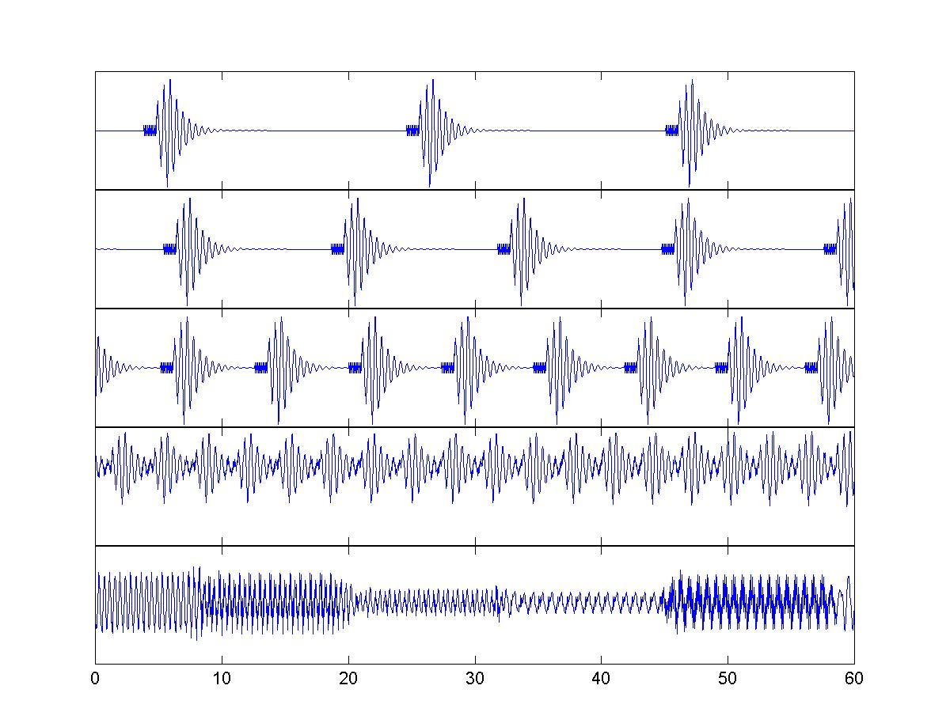
Figure 1: Synthetic seismogram showing how hybrid earthquakes could merge into continuous tremor. Each hybrid is identical and consists of a 10-Hz onset and a much larger 2-Hz coda. This waveform is convolved with a series of delta functions becoming closer and closer together in time. The x-axis is seconds. Panels from top to bottom are each 10-minutes apart. By panel 4 the individual hybrids are beginning to overlap. In panel 5 they have merged into tremor. It would be interesting to apply a standard sta:lta detection algorithm to these data and see at what point detection breaks down.

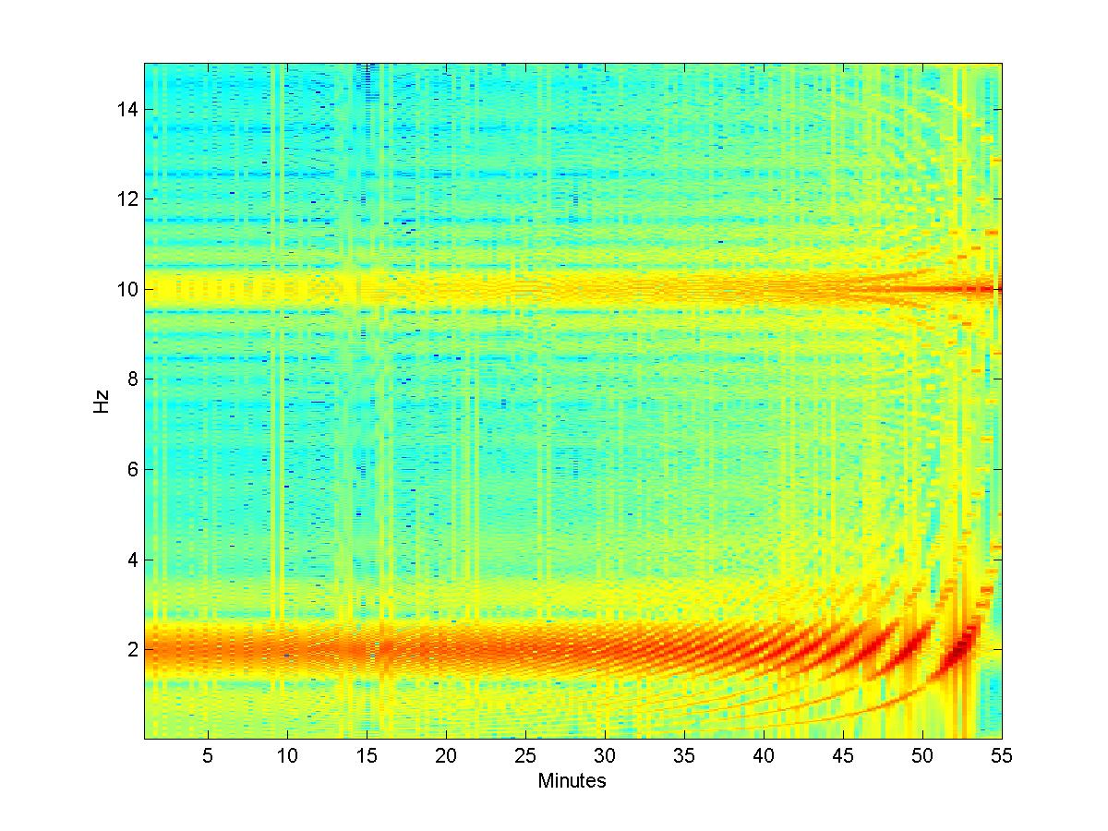
Figure 2: Spectrogram of the synthetic hybrid swarm shown in Figure 1. Each hybrid consists of a 10-Hz onset and a much larger 2-Hz coda. These peaks are spliced in the spectrogram, and as hybrids begin to emerge, gliding spectral lines are observed.

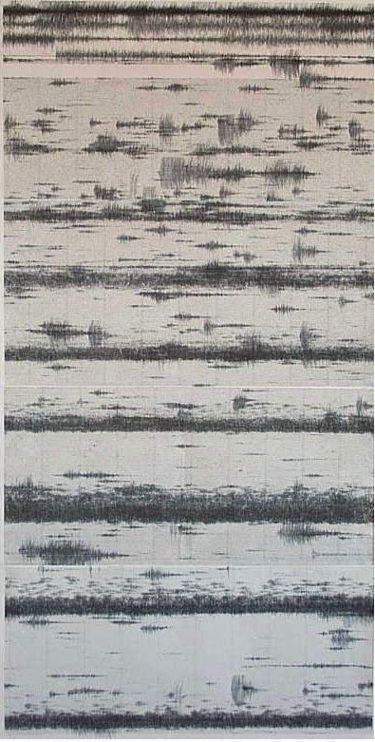
Figure 3: “Banded tremor” and hybrid earthquakes as they appear on a helicorder. Here several drum records were taped together and photographed, as the tremor bands occurred over several days, and MVO drum records had to be changed every 24 hours. This example is from 26 Feb 2001 – 1 Mar 2001, station MRYT. Tremor bands are 12-15 hours apart.

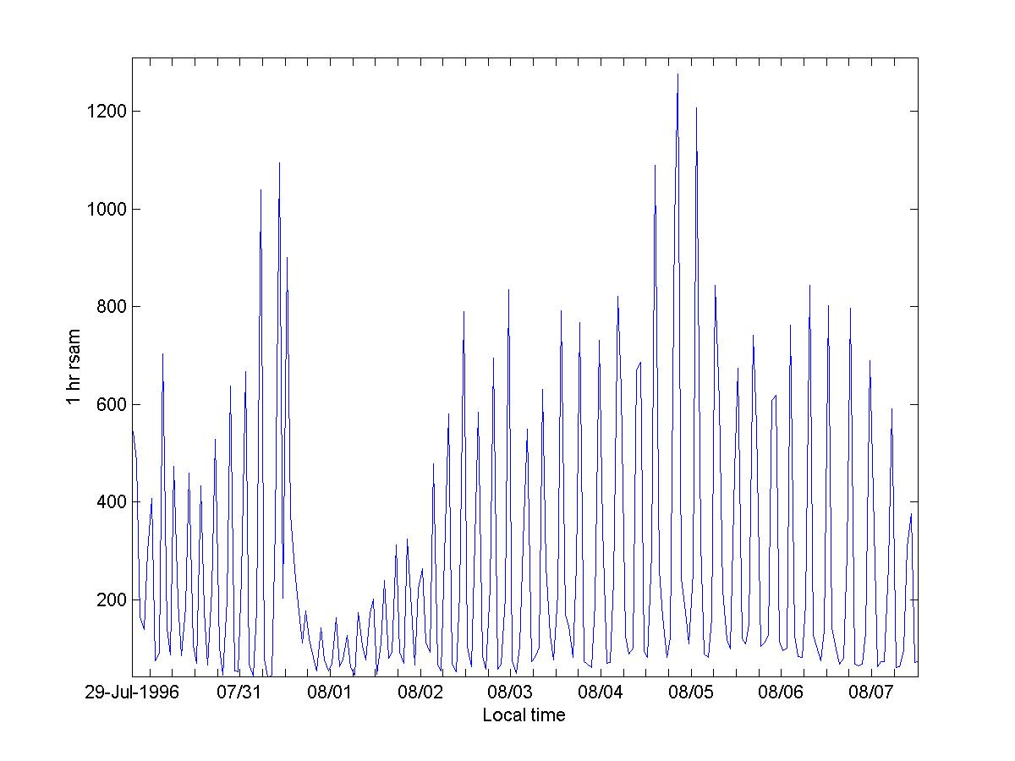

Figure 4: RSAM data show seismicity cycles very clearly. RSAM is a time-averaged measure of seismic amplitude. It does not distinguish between different types of seismicity such as rockfalls, hybrids, regional earthquakes, etc.

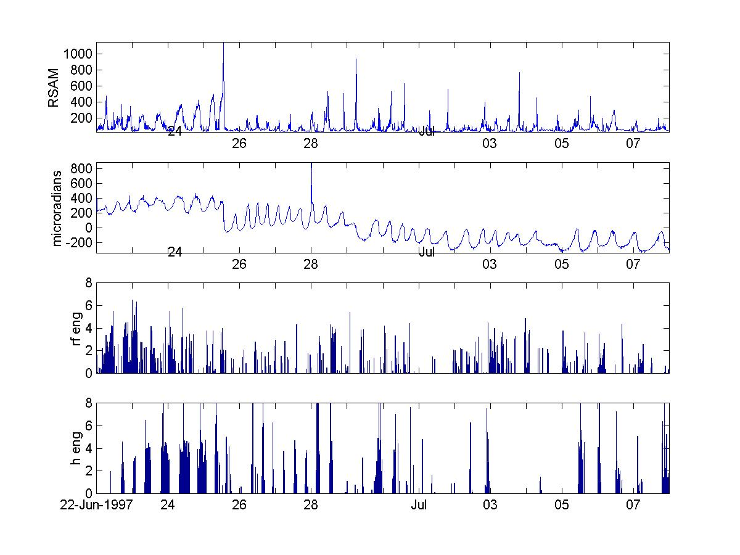
Figure 5: Correlation of tremor cycles, radial tilt cycles on CHP3, rockfall energy and hybrid earthquake energy. Hybrid and RSAM cycles generally occur simultaneously. Rockfall cycles are less clear. Note the abrupt change following the fatal dome collapse of 25 June 1997. The cycles leading up to that collapse are particularly prominent, and suggest that autodetection of seismicity cycles is a valuable hazard analysis tool for a volcano observatory to have. Following the collapse, the amplitude of the cycles are much smaller. This same observation was noted in July-August 1996 [Thompson, 1996].

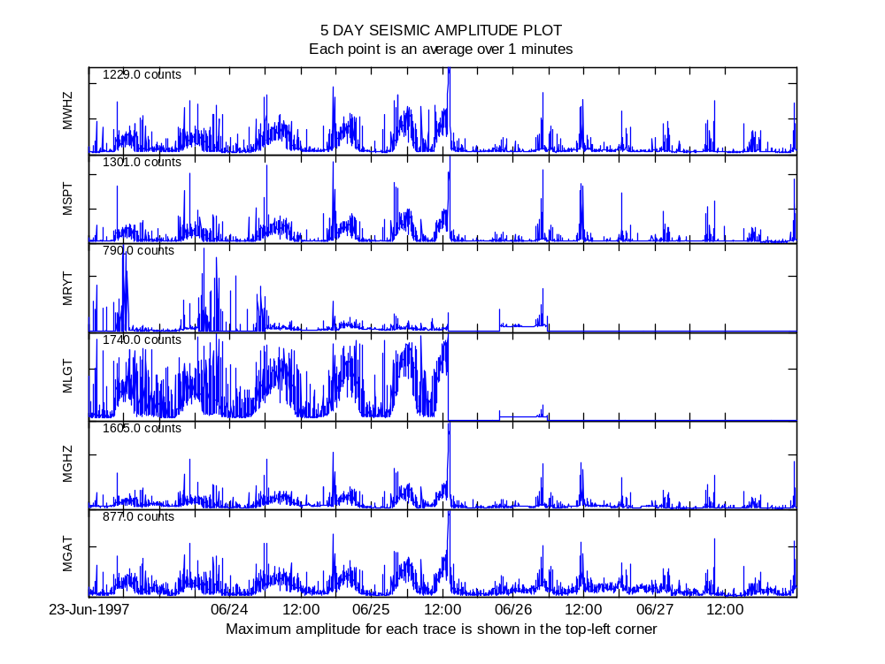
Figure 6: Strong seismicity cycles prior to the 25 June 1997 collapse were recorded across the whole analog seismic network. Note that stations MLGT and MRTY cut out following the event, probably due to ash in the air affecting telemetry, and then ash on the solar panels preventing the batteries recharging. The collapse itself (around 13:00) is particularly prominent on MGHZ and MWHZ indicating the main activity was to the north.
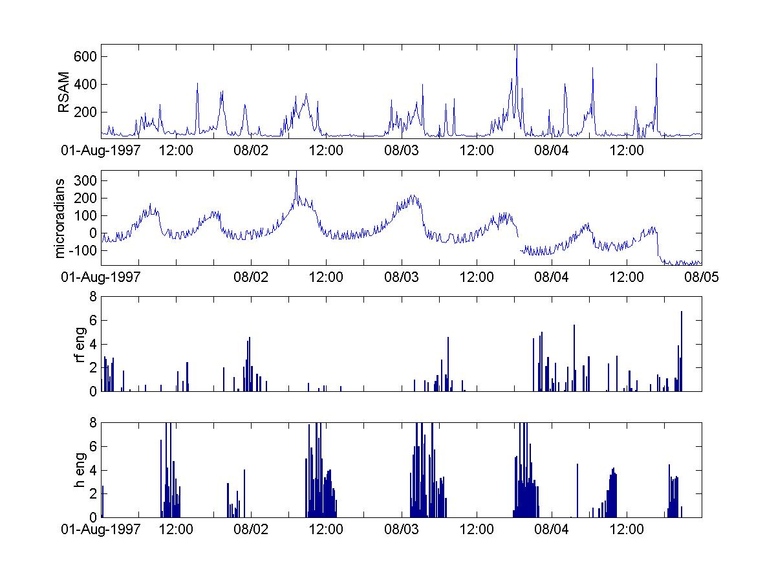
Figure 6: From top to bottom are shown RSAM data, tilt data, seismic energy corresponding to detected rockfalls and the same for detected hybrid earthquakes. First note that the tilt cycles are much clearly than the seismicity cycles, which is probably because the seismicity was recorded much further from the volcano. Second note that the tilt cycles shown here develop gradually, and end abruptly. Note also that hybrid earthquakes appear at the end of tilt cycles. This gives a false picture. The seismicity bands are composed of hybrid earthquakes, but once they began to overlap and merge into tremor, there is no longer any sharp change in short compared to long term average, and so the event detection software does not trigger. This is a drawback of using an STA:LTA algorithm for detecting volcano-seismic events.
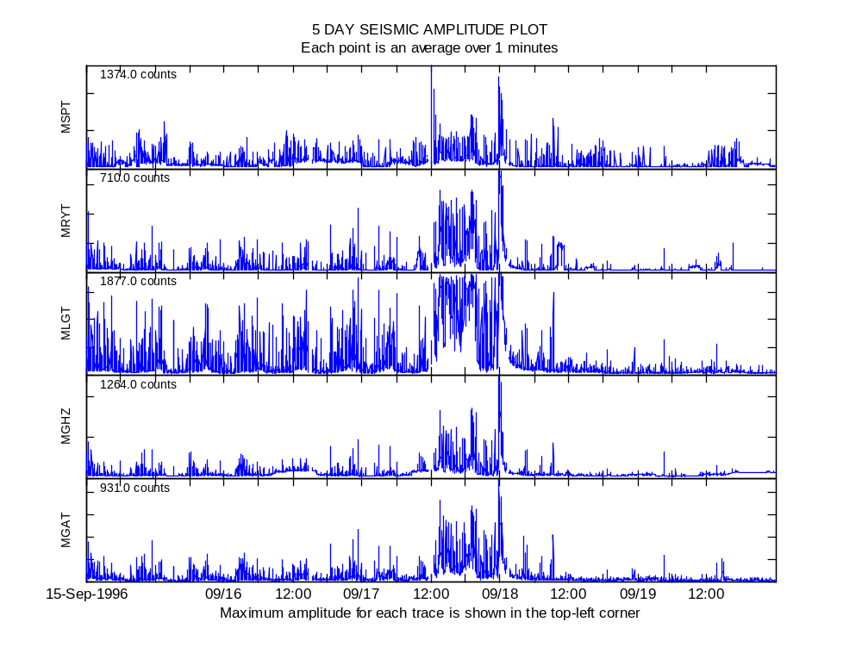
Figure 7: There is clear evidence of cyclic seismicity mmediately prior to the 17 September 1996 collapse, which was the most significant collapse to that time. The cycle period is around 7 hours, but the amplitude is small. This observation is not mentioned in the MVO Special Report written about this major event, even though cyclic seismicity had been noted since late July.

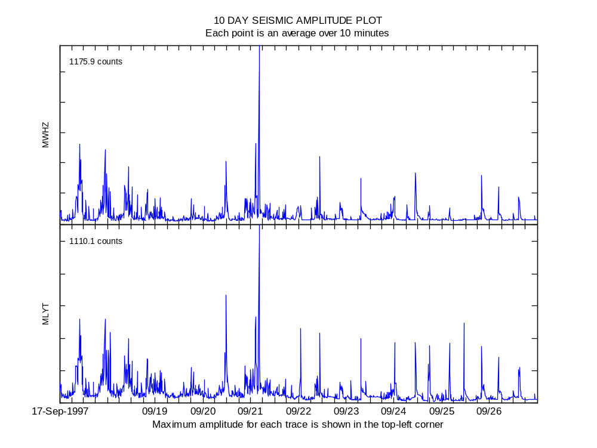
Figure 8: Clear evidence of cyclic seismicity before the dome collapse on 21 September 1997. The pattern afterwards isn't as clear.
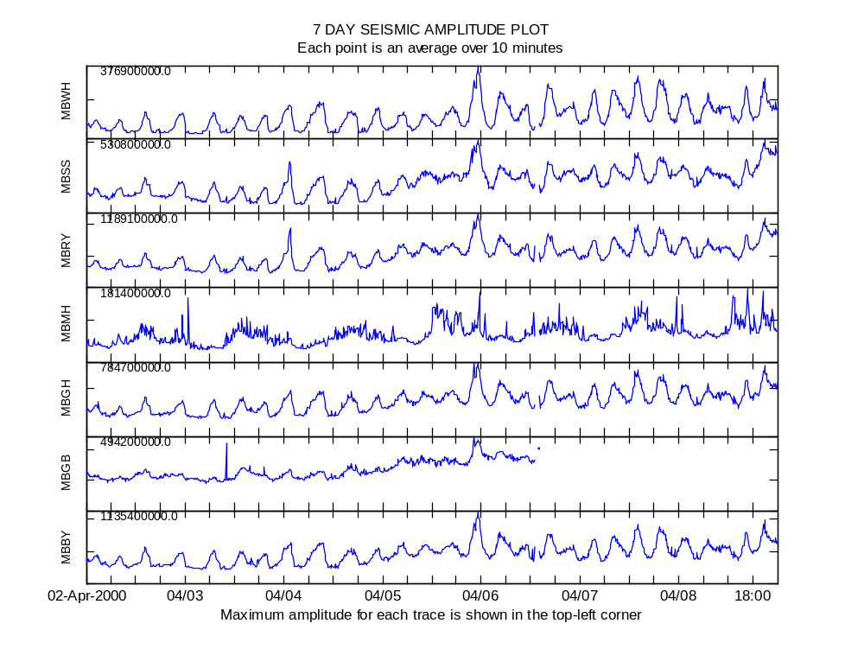
Figure 9: Strong seismicity cycles shown here 2-3 weeks following the major rainfall-triggered dome collapse on 20 March 2000.

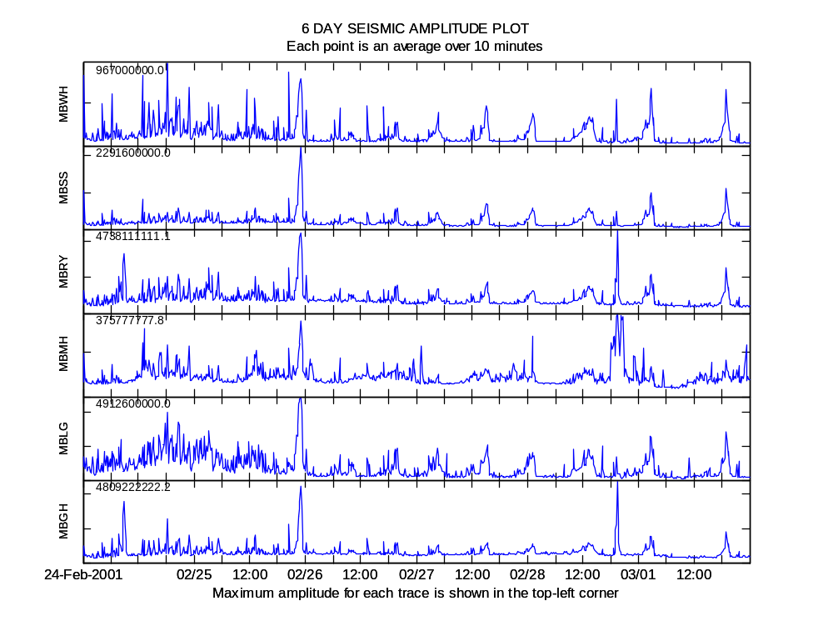

Figure 10: Strong seismicity cycles following the collapse on 25 February 2001.
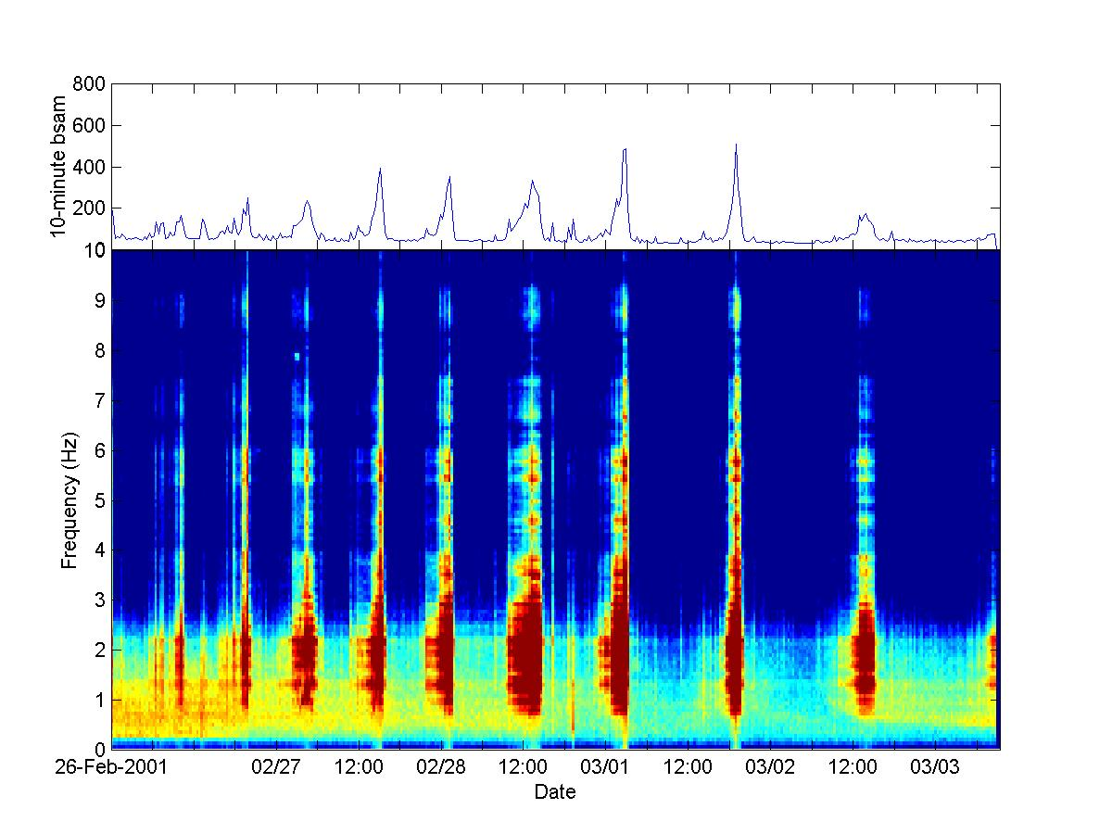
Figure 11: A spectrogram [bottom] of the seismicity cycles that occurred from 26 February to 03 March 2001, with the associated RSAM plot [top]. The dominant frequency range is 1 – 3 Hz, as is typical for low frequency volcano seismicity.

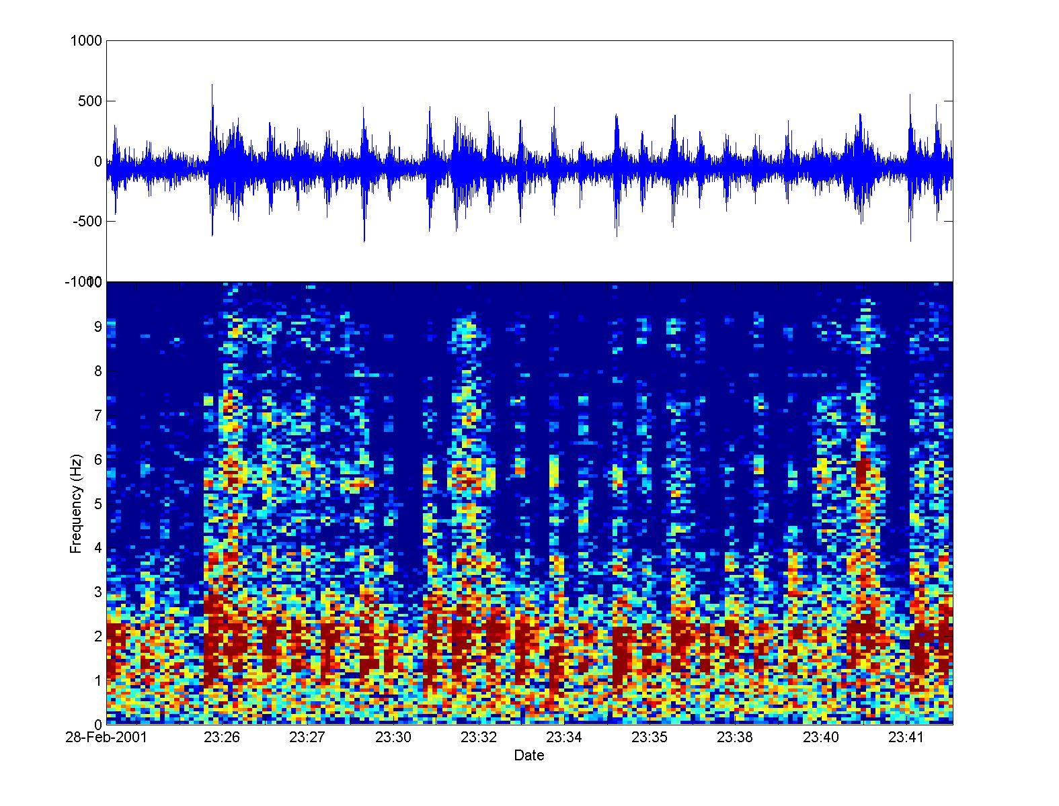
Figure 12: A seismicity cycle from 28 February 2001 where events had not yet merged into tremor.

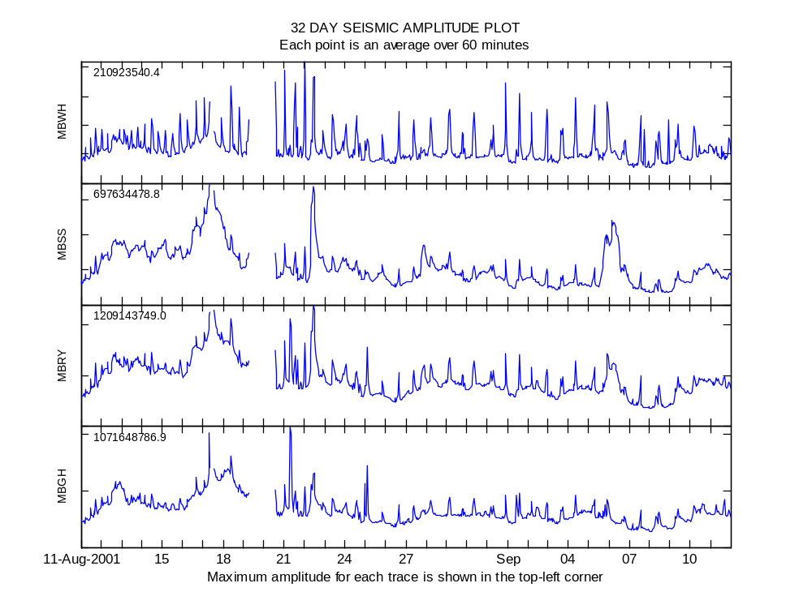
Figure 13: Cyclic seismicity clearly becoming visible about 2 weeks after the 29 July 2001 collapse.

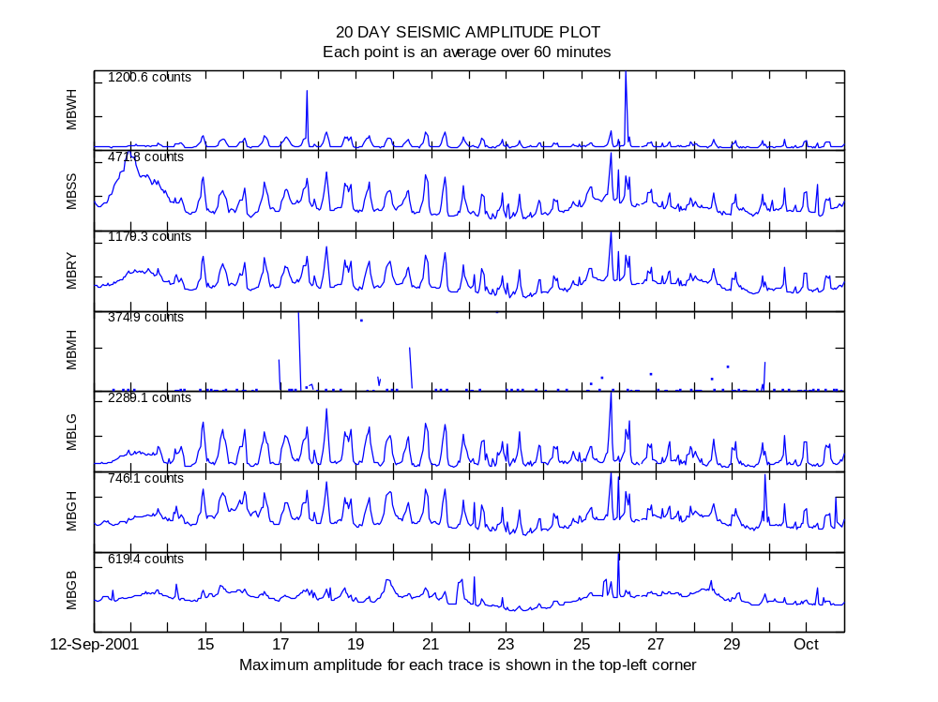
Figure 14: Cyclic seismicity still continuing 6 weeks after the 29 July 2001 collapse.
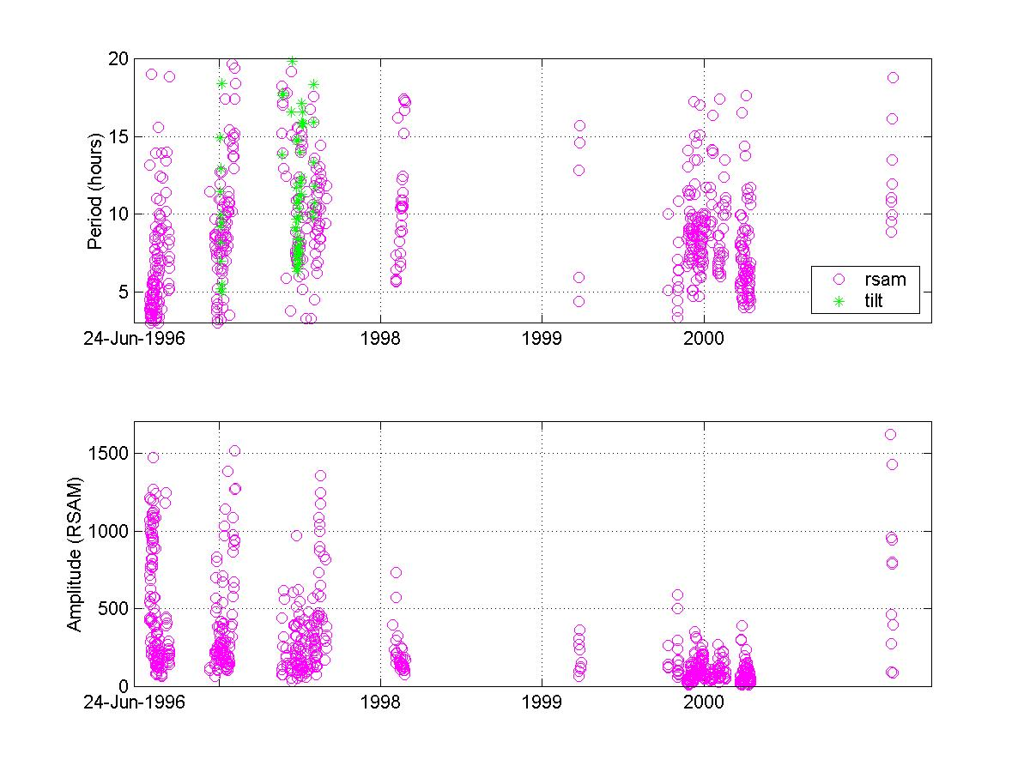
Figure 15: Output from the program detectcycles.m. Summary of all detected tremor bands until May 2001. The top panel shows the period which ranges from about 3 to 20 hours. The bottom panel shows the amplitude, measured in equivalent counts for station MBWH.

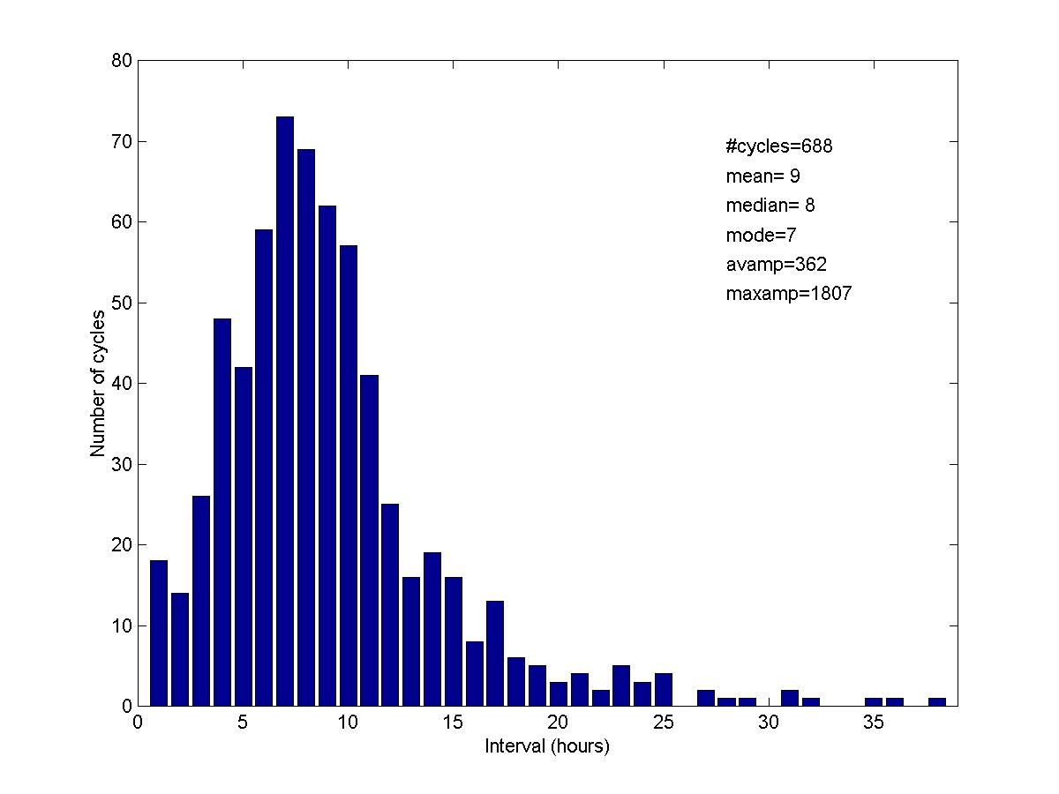

Figure 16: This graph shows the spread of tremor band period for all cycles recognized up to May 2001. The distributed is skewed, with the mode, median and mean taking different values in the range of 7 to 9 hours. All amplitudes are shown in counts on station MBWH, and are converted from other stations where necessary.

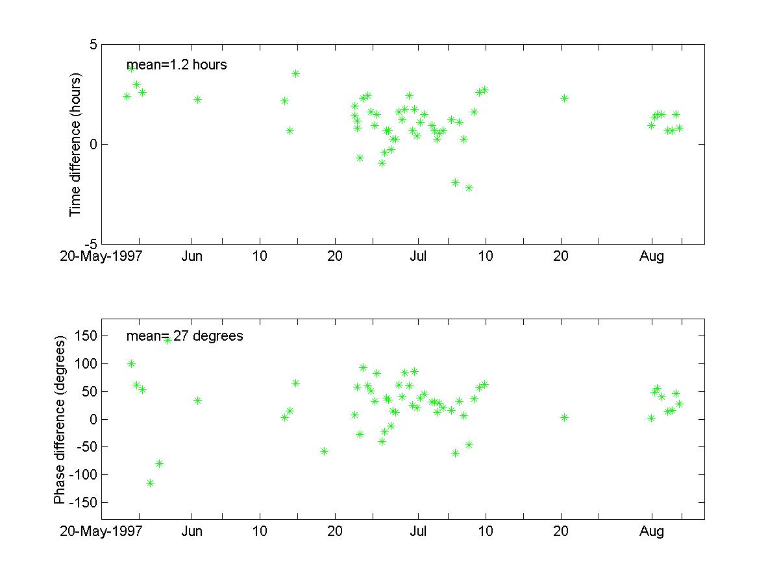
Figure 17: The time relationship between tilt and seismicity cycles for the period May – August 1997. Tilt usually leads seismicity, and by an average of 1.2 hours [top]. Since the period varies, it perhaps is more meaningful to examine the phase difference. Tilt leads seismicity on average by 27 degrees. Its important however than models take account of the observation that seismicity sometimes leads tilt. Since the onsets of cycles are difficult to identify, it is the time of the peak of the tilt and seismicity cycles that are compared here.
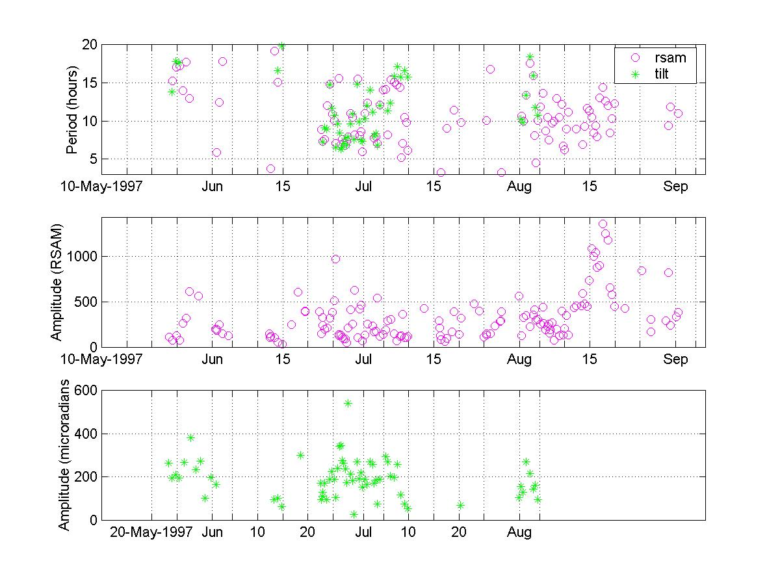

Figure 18: Here the periods [top] and amplitudes [middle and bottom] of tilt and seismicity cycles are compared. Visually, the correlation looks strong, suggesting these signals are related. Plots of tilt period vs. seismicity period, and tilt amplitude vs. seismic amplitude would be useful to better judge this.

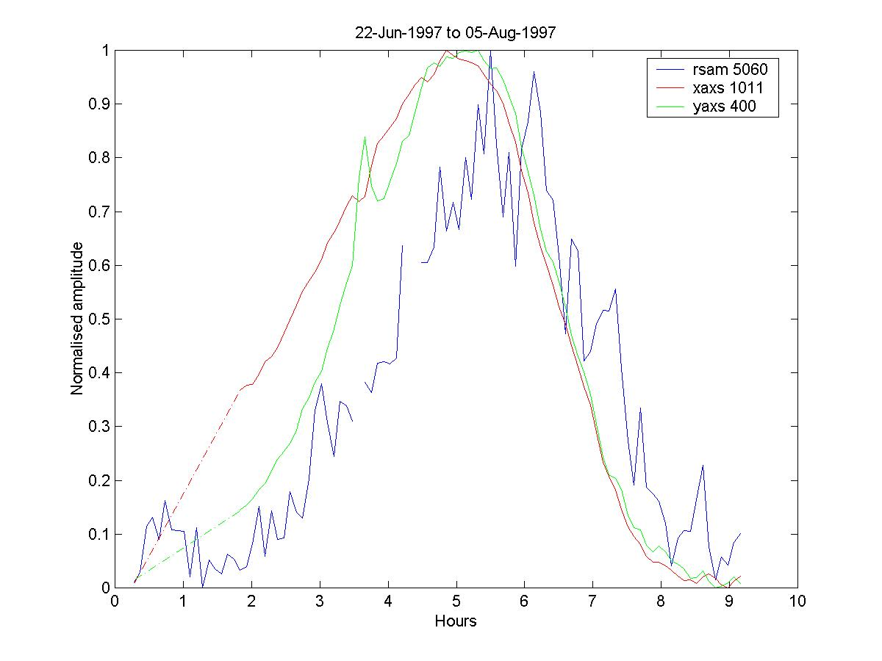
Figure 19: Average shape of a seismicity and a tilt cycle from 1997. These graphs were formed by identifying onset times and aligning them accordingly. The average period is about 8 hours. For the tiltmeter, the X-axis points towards volcano (radial) and the Y-axis is perpendicular (transverse). X-axis tilt leads initially and is fairly symmetrical. Tilt on both axes peaks at the same time and leads peak seismicity by about 1.2 hours. Following the peak in seismicity, all 3 parameters drop quickly. The fall in seismicity is punctuated by a series of bumps caused by rockfall activity, which seems to be provoked by the depressurization. Whether this is because of gas exhalation destabilizing the dome, or changes in the rate of extrusion, is not clear.

